JACQUES LEMANS CLASSIC DUBLIN

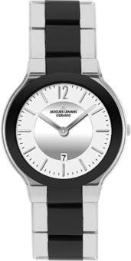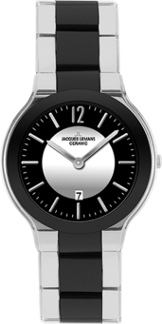
1-1472 C 1-1472 B

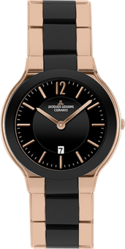
1-1472 D

