AZZARO
COASTLINE

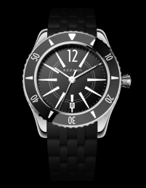

AZ2200–12AA-01A AZ2200-12BB-01B

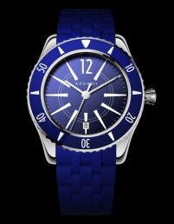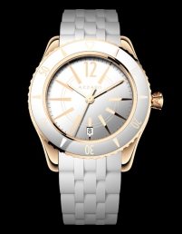

AZ2200-12EE-01E AZ2200-52AA-05A

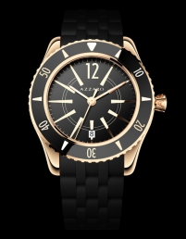

AZ2200-52BB-05B AZ2200-52BB-050

